What is Software Testing

Software testing is a process of identifying the correctness of software by considering its all attributes (Reliability, Scalability, Portability, Re-usability, Usability) and evaluating the execution of software components to find the software bugs or errors or defects.

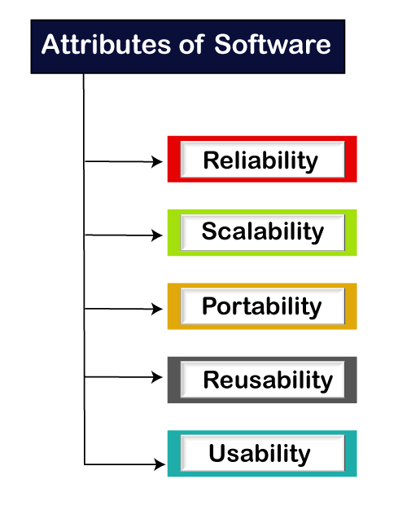

Software testing provides an independent view and objective of the software and gives surety of fitness of the software. It involves testing of all components under the required services to confirm that whether it is satisfying the specified requirements or not. The process is also providing the client with information about the quality of the software.

Testing is mandatory because it will be a dangerous situation if the software fails any of time due to lack of testing. So, without testing software cannot be deployed to the end user.

## Type of Software testing

We have various types of testing available in the market, which are used to test the application or the software.

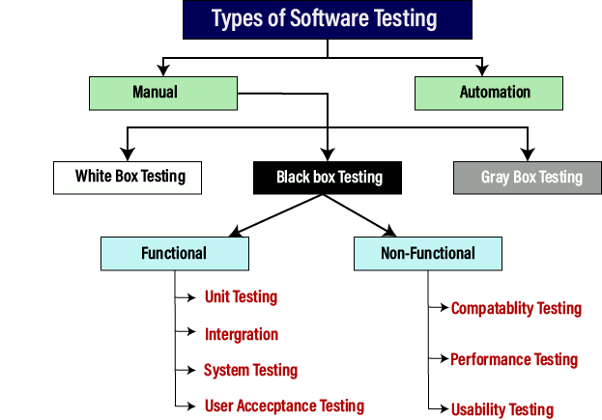

### Manual testing

The process of checking the functionality of an application as per the customer needs without taking any help of automation tools is known as manual testing. While performing the manual testing on any application, we do not need any specific knowledge of any testing tool, rather than have a proper understanding of the product so we can easily prepare the test document.

Manual testing can be further divided into three types of testing, which are as follows:

* **White box testing**
* **Black box testing**
* **Gray box testing**

### Automation testing

Automation testing is a process of converting any manual test cases into the test scripts with the help of automation tools, or any programming language is known as automation testing. With the help of automation testing, we can enhance the speed of our test execution because here, we do not require any human efforts. We need to write a test script and execute those scripts.